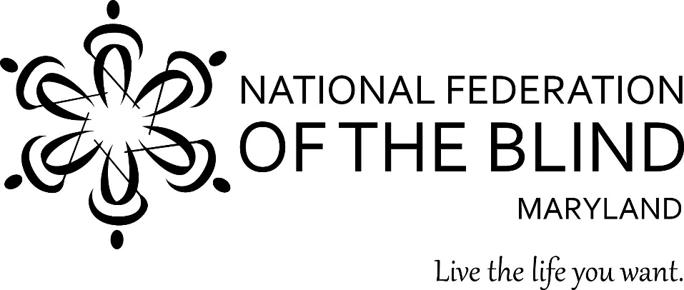

Subject: Restoring the Secret Ballot to Disabled Voters to Assure Equality in Voting
To: Members of the Maryland General Assembly
From: Members of the National Federation of the Blind of Maryland
Contact: Sharon Maneki, Director of Legislation and Advocacy
National Federation of the Blind of Maryland
9013 Nelson Way
Columbia, MD 21045
Phone: 410-715-9596
Email: nfbmdsm@gmail.com

Date: January 2021

THE PROBLEM
For most of its history, all voters in Maryland used the same voting system. This situation changed in the 2016 and 2018 elections because the Maryland State Board of Elections (SBE) created two systems of voting: the ExpressVote electronic ballot marking device (BMD), and the paper-based system in which ballots are marked by hand. The SBE has selected the voter-verifiable paper-based solution leased from Election Systems and Software (ES&S) as its BMD. Unfortunately, in 2016 and 2018, SBE limited the use of this BMD by deploying only one device to each polling place. The SBE has further limited the use of these BMDs by requiring only two voters per polling place to use the BMD. In the 2020 elections, due to COVID-19, SBE encouraged voters to cast their ballots by mail. Those voters who chose to vote in person were informed that they could cast their ballot either by using the BMD or by using a paper ballot. Many blind and disabled voters are forced to use the ES&S BMDs to cast their ballots because they cannot use the hand marked ballots.
The problem for blind and disabled voters is that the BMDs produce paper ballots that are smaller in size and differ in content from the hand marked ballots. Thus, in the 2016 and 2018 elections, ballots cast by blind and disabled voters were segregated and too easily identifiable in the overall collection of ballots. Therefore, ballots cast by blind and disabled voters were no longer secret. Maryland no longer had equality in voting. In the 2020 general election, for in person voting, voters with disabilities continued to face discrimination due to segregation. The problem of loss of voter secrecy still remains because SBE policies are arbitrary and inconsistent.
IILLUSTRATION OF BOTH SAMPLE BALLOTS, SIDE BY SIDE
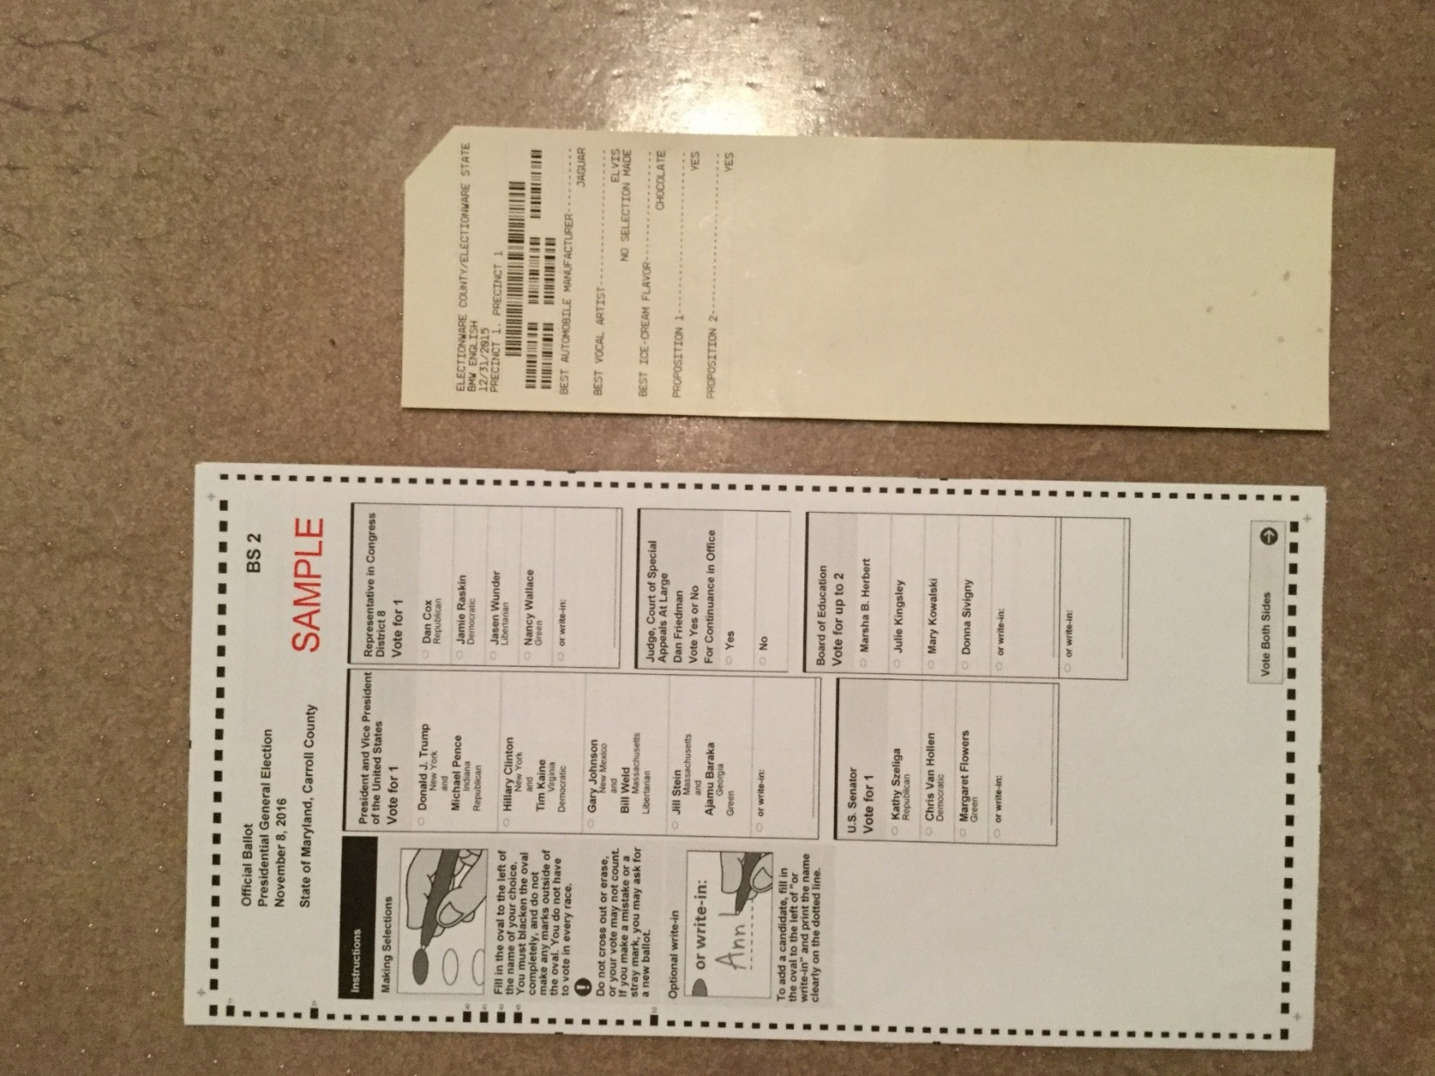

PROPOSED ACTION
The Maryland General Assembly should enact legislation requiring the SBE to create one voting system for all in-person voters in Maryland. The preamble of this legislation should state that there shall be no discrimination on the basis of disability in the voting process. The practice of using segregated ballots must be eliminated.
BACKGROUND
At the end of the 20th century, Maryland began to modernize its voting system. Gradually, Maryland introduced voters to a touch screen electronic system with all jurisdictions using the same system beginning in the 2004 elections. Voters with disabilities were most pleased because the nonvisual access of this new voting system allowed us to vote secretly and in private for the first time. However, this touch screen system did not produce paper ballot records which would be essential for the purposes of recounts and verification. The SBE was then forced to adopt a new voting system that was capable of producing paper ballot records. This new voting system was first used in the 2016 election.
The state of Maryland was unwilling to spend the money that was needed to purchase enough BMDs for all voters to use in the 2016 elections. This shortage led SBE to deploy only one BMD in each polling place, which forced most voters to mark their ballots by hand. This decision was the beginning of the loss of the secret ballot for blind and disabled voters.
In the 2016 primary election, candidates whose names appeared on the second or third screens of the BMD threatened legal action, complaining that navigating to these screens was too difficult. To appease these candidates, SBE further limited the use of the BMDs by requiring only two voters per polling place to use them. This policy forced even more voters to mark their ballots by hand and increased the loss of the secret ballot for blind and disabled voters. In the summer of 2019, SBE attempted to appease blind and disabled voters by changing the number of voters that would be encouraged to use the BMD from two to five. This new policy also allowed polling places to receive two machines, if desired, instead of one. Jurisdictions could also apply to SBE in writing and request up to four machines. These policy changes will not eliminate segregation or the loss of the secret ballot.

Maryland Election Law Article §9-102(f)(1), Annotated Code of Maryland, states that a voting system selected and certified by the SBE shall "provide access to voters with disabilities that is equivalent to access afforded voters without disabilities without creating a segregated ballot for voters with disabilities."
On December 18, 2013, the Attorney General of Maryland issued an opinion stating that if SBE chooses to certify an accessible ballot marking device that produces a ballot that is different in size and/or content from the hand-marked ballots, SBE “must establish randomized polling-place procedures to ensure that a significant number of non-disabled voters will use the accessible voting system to protect the secrecy of the ballots cast by voters with disabilities.” Requiring only five voters to use the BMD does not meet the definition of randomized polling procedures. We emphasize again that this five-voter minimum requirement denies blind and disabled voters the right to a truly secret ballot.
CRITICAL ERRORS BY THE SBE
The experience of the 2016 primary and general elections demonstrated that all voters had little difficulty in navigating the multiple screens on the BMD. Although the concerns of the candidates were baseless, SBE still refused to change its two-voter policy for the 2018 elections. SBE also chose to disregard the concerns of disabled voters about their loss of the secret ballot.
The National Federation of the Blind of Maryland (NFBMD) maintains that balancing the rights of voters against the complaints of candidates does not justify a system that:
(1) creates physical segregation of voters with disabilities;
(2) causes the segregation of their ballots according to physical appearance and content;
(3) jeopardizes the privacy of their votes.
This was the reason language prohibiting a segregated ballot was included in Maryland Election Law Article §9-102(f)(1), Annotated Code of Maryland.
We emphasize again that there were no reports of voters having difficulty with navigation during the 2016 election season. The issue of ballot order bias exists for both hand marked ballots and BMDs. While most studies agree there is a positive impact on candidates listed first, there is not a consensus on size of the impact.
FAILURE TO IMPLEMENT BMD USAGE POLICY
In the 2016 and 2018 elections, disabled voters were deprived of the guarantee of a secret ballot that has always been afforded to non-disabled voters. In the 2020 general election, this problem continued for disabled voters who casted their ballot in person. The SBE data from the 2016 and 2018 elections demonstrates that the already inadequate SBE policy encouraging two voters in every precinct to use the BMD was a failure. Given that numerous polling locations were unable to compel even two individuals to use the BMD, the Board’s policy change of five users of the BMD per polling location will likewise fail.
In the 2016 general election, twelve of the twenty-four counties or county equivalents in Maryland had at least one precinct where only one voter used the BMD. The SBE did not provide the data for precincts with zero voters using the BMD. See Appendix A for details.
The loss of the secret ballot by disabled voters was even worse in 2018 than it had been in 2016. Several primary elections were very close, which resulted in the recounts of votes. The BMD ballots were definitely identifiable during these recounts. In the 2018 primary election, nine counties had polling places where only one vote was cast using the BMD. Once again, SBE did not provide the data for precincts with zero voters using the BMD. See Appendix B for details.
In the 2018 general election, nine counties had at least one precinct where only one voter used the BMD machine. Nine counties also had at least one precinct where zero voters used the BMD machine. See Appendix C for details.
In the 2020 general election, nine counties had at least one precinct where only one voter used the BMD machine during the early voting period. See Appendix D1 for details. On election day itself, thirteen counties had at least one precinct where only one voter used the BMD machine. See Appendix D2 for details. Data was not available for the 2020 primary.
CONCLUSION
The SBE violated Maryland Law by creating a segregated ballot for persons with disabilities. It also ignored the opinion of the Attorney General by creating policies that did not permit true randomization of the use of BMDs by both disabled and non-disabled voters. Consequently, voters with disabilities who must use the BMD no longer have a secret ballot. Although we brought these problems to the attention of SBE, the General Assembly, and the Governor, they took no action. Blind and disabled voters will still face segregation and the loss of the secret ballot in future elections. It is time for Maryland to go back to its practice of using one voting system for all of its citizens who choose to vote in-person.
Members of the National Federation of the Blind of Maryland urge the Maryland General Assembly to enact legislation that creates one voting system for all in-person voters in Maryland. The Supreme Court ruled that separate is not equal 66 years ago. It is time for Maryland to recognize this truth by eliminating discrimination against voters with disabilities. If the ballots of any other protected class of citizen were identifiable, the General Assembly would surely insist that SBE revise its policies. Blind and disabled voters deserve the right to equality in voting and a secret ballot, too.
Appendix A
2016 GENERAL ELECTION DATA
According to the Maryland State Board of Elections (SBE) data, 12 of the 24 counties or county equivalents in Maryland had at least one precinct where only one voter used the BMD machine. Those locations are:
County | Poll Name | ExpressVote Ballot Cast
Anne Arundel | Earleigh Heights VFD | 1
Anne Arundel | Southern Middle School | 1
Anne Arundel | Odenton Regional Library | 1
Baltimore City | Engine House No. 2 | 1
Baltimore City | Murty Center- Poe Auditorium | 1
Baltimore County | Kingsville Elementary School | 1
Baltimore County | Hernwood ES Cafeteria | 1
Baltimore County | Stembridge Community Center | 1
Baltimore County | Middle River VFD Hall | 1
Baltimore County | Long Green VFC Hall A | 1
Baltimore County | Gunpowder ES Gym | 1
Baltimore County | Pinewood ES Cafeteria | 1
Baltimore County | Warren ES Gym | 1
Baltimore County | Owings Mills HS Senior Café | 1
Baltimore County | Wards Chapel Methodist Church Hall | 1
Baltimore County | Church Lane ES M/P Rm | 1
Carroll | Francis Scott Key HS Band Room | 1
Charles | LaPlata High School Commons Area | 1
Cecil | Bayview Elementary School S | 1
Dorchester | North Dorchester MS Foyer | 1
Dorchester | South Dorchester K-8 School | 1
Harford | Old Post Road Elementary School | 1
Howard | Northfield ES Cafeteria | 1
Howard | Lisbon VFD Hall | 1
Howard | Howard HS Gym | 1
Prince George’s | Kettering Elementary School | 1
Prince George’s | Greater Lighthouse Church | 1
Prince George’s | Cesar Chavez Elementary SCHL | 1
Prince George’s | Hyattsville Public Library | 1
Washington | Washington County Technical HS | 1
Washington | Williamsport High School | 1
Wicomico | Faith Baptist Church Salisbury | 1
Wicomico | East Side VFW Memorial Post 2996 | 1
Wicomico | Sharptown Firemens Memorial Bldg | 1

Appendix B

2018 PRIMARY ELECTION DATA

According to SBE data, nine counties had polling places where only one vote was cast using the BMD.
County | Poll Name | ExpressVote Ballot Cast | Total Ballot Cast
Anne Arundel | Brooklyn Park Community Library | 1 | 159
Anne Arundel | Northeast High School | 1 | 205
Baltimore City | Murty Ctr-Poe Auditorium | 1 | 71
Baltimore City | School #27 Rodgers Elem | 1 | 76
Baltimore City | School #13 Tench Tilghman Elem | 1 | 13
Baltimore City | School #7 Cecil Elem | 1 | 54
Baltimore City | School #122 - Samuel Coleridge-Taylor Elem | 1 | 7
Baltimore City | School #53 Brent Elem | 1 | 373
Baltimore City | School #53 Brent Elem | 1 | 214
Baltimore City | School #39 Dallas F. Nicholas Sr. Elem | 1 | 132
Baltimore City | Enoch Pratt Free Library Pennsylvania Ave Br | 1 | 67
Baltimore City | School #28 William Pinderhughes Elem | 1 | 9
Baltimore City | School #4 Steuart Hill Elem | 1 | 172
Baltimore City | School #4 Steuart Hill Elem | 1 | 52
Baltimore City | Mary E. Rodman Rec Ctr | 1 | 300
Baltimore City | Academy of Success | 1 | 19
Baltimore City | Community Building | 1 | 54
Baltimore City | School #235 Glenmount Elem/Mid | 1 | 156
Baltimore City | Govans Boundary Umc | 1 | 253
Baltimore County | Maiden Choice School - Gym | 1 | 250
Cecil | 5-5 Bayview Elementary School | 1 | 332
Harford | Magnolia Elementary School | 1 | 235
Harford | Edgewood Elementary School Cafeteria | 1 | 137
Harford | Edgewood Recreation & Community Center | 1 | 174
Harford | Emmorton Elementary School | 1 | 431
Harford | Joppatowne High School | 1 | 368
Harford | Aberdeen Senior High School Cafeteria | 1 | 321
Harford | Forest Lake Elementary School | 1 | 557
Howard | Running Brook Elem School - Cafeteria | 1 | 255
Montgomery | Chevy Chase United Methodist Church | 1 | 320
Montgomery | Stedwick Elementary School | 1 | 429
Prince Georges | Harmony Hall Regional Center | 1 | 509
Prince Georges | William Beanes Elem Sch | 1 | 289
Prince Georges | Pgcps Bldg. | 1 | 480
Prince Georges | Benjamin D. Foulois Creative & Performing Arts | 1 | 100
Prince Georges | Northview Elem. Sch. Cafe. - A. | 1 | 199
Prince Georges | Benjamin Tasker Middle Sch | 1 | 175
Prince Georges | Waldon Woods Elem Sch | 1 | 751
Washington | Washington County Technical Hs | 1 | 119
Washington | Big Pool Community Hall | 1 | 242

Appendix C

2018 GENERAL ELECTION DATA

In the 2018 general election, nine counties had at least one precinct where only one voter used the BMD machine. Nine counties also had at least one precinct where zero voters used the BMD machine.
County | Poll Name | ExpressVote Ballot Cast | Total Ballot Cast
Anne Arundel | Annapolis Middle School | 0 | 549
Anne Arundel | Roger "pip" Moyer Recreation Center | 0 | 320
Anne Arundel | Roger "pip" Moyer Recreation Center | 0 | 11062
Anne Arundel | Lindale Middle School | 1 | 806
Anne Arundel | Severna Park Middle School | 1 | 656
Baltimore City | Engine House #5 | 0 | 744
Baltimore City | School #16 Johnston Sq Elem | 0 | 156
Baltimore City | School #55 Hampden Elem | 0 | 49
Baltimore City | School #28 William Pinderhughes Elem | 0 | 27
Baltimore City | School #122 Samuel Coleridge-Taylor Elem | 0 | 41
Baltimore City | School #225 Westport Elem | 0 | 276
Baltimore City | Engine House #51 | 0 | 130
Baltimore City | Engine House #42 | 0 | 599
Baltimore City | Grace United Methodist Church (040) | 0 | 765
Baltimore City | Grace United Methodist Church (041) | 0 | 822
Baltimore City | School #122 Samuel Coleridge-Taylor Elem | 1 | 15
Baltimore City | Solo Gibbs Rec Ctr | 1 | 466
Baltimore City | St Nicholas Church Hall | 1 | 417
Baltimore City | Carroll Cook Rec Ctr | 1 | 259
Baltimore City | Open Bible Baptist Church | 1 | 330
Baltimore County | Ridge Ruxton School- Multi Purpose Rm | 0 | 899
Baltimore County | Colgate Elementary School - Cafe | 0 | 454
Baltimore County | Sussex Elementary School-Gym | 0 | 765
Baltimore County | Warren Elementary - Gym | 1 | 1199
Baltimore County | White Marsh Library-Meeting Room | 1 | 187
Charles | St Ignatius Church Hall, Hilltop | 0 | 650
Charles | Trinity Church Hall, Newport | 0 | 1034
Charles | St Marys School Bryantown | 1 | 194
Frederick | Mt Pleasant Ruritan Club | 1 | 2212
Harford | Trinity Lutheran School | 0 | 1510
Harford | Edgewood Elementary School Cafeteria | 0 | 462
Harford | Joppatowne Elementary School | 0 | 1207
Harford | Deerfield Elementary School | 0 | 672
Harford | Abingdon Fire Hall | 0 | 1274
Harford | Old Post Road Elementary School | 0 | 1834
Harford | Church Creek Elementary School | 0 | 2456
Harford | Highlands School | 0 | 782
Harford | St. Mary's Episcopal Church Emmorton | 0 | 323
Harford | Riverside Elementary School | 0 | 889
Harford | Level Fire Hall | 0 | 1661
Harford | Aberdeen Vfw 10028 | 0 | 534
Harford | Hickory Elementary School | 0 | 818
Harford | Forest Hill Elementary School | 0 | 1951
Harford | Mountain Christian Church | 0 | 1288
Harford | Newport Terrace | 0 | 1302
Harford | Forest Lake Elementary School | 0 | 1541
Harford | Bel Air Elementary School Gym | 0 | 987
Harford | Mt. Ararat Lodge | 0 | 808
Harford | Bel Air Middle School | 0 | 843
Harford | Red Pump Road Elementary School | 0 | 1360
Harford | Bel Air High School | 0 | 837
Harford | Southampton Middle School | 0 | 2007
Harford | Wakefield Elementary School | 0 | 995
Harford | C. Milton Wright High School | 0 | 1267
Harford | Prospect Mill Elementary School | 0 | 1029
Harford | Fountain Green Elementary School | 0 | 1303
Harford | St. Matthew Lutheran Church-Great Hall | 0 | 1188
Harford | Victorious Faith Fellowship Church | 0 | 949
Harford | Jarrettsville Elementary School Cafeteria | 0 | 1108
Harford | Youth's Benefit Elementary School | 0 | 1154
Harford | Norrisville Elementary School | 0 | 1297
Harford | North Bend Elementary School | 0 | 1067
Harford | Veronica 'roni' Chenowith Activity Center | 0 | 1245
Harford | Jarrettsville Library | 0 | 723
Harford | North Harford Elementary Cafeteria | 0 | 1193
Harford | Darlington Elementary School | 0 | 717
Harford | Havre De Grace High School | 0 | 768
Harford | Meadowvale Elementary School | 0 | 1120
Harford | Havre De Grace Elementary School | 0 | 859
Harford | Havre De Grace Middle School | 0 | 1557
Harford | Abingdon Elementary School Gym | 1 | 2118
Harford | Fallston Senior High School Cafeteria | 1 | 1737
Harford | Ring Factory Elementary School | 1 | 838
Harford | Harford Technical High School | 1 | 1374
Harford | Dublin Elementary School | 1 | 1270
Harford | North Harford High School | 1 | 1123
Howard | Manor Woods Elem School - Cafeteria | 0 | 852
Montgomery | Martin Luther King, Jr. Middle School | 0 | 1256
Montgomery | Capt. James E. Daly, Jr. Elementary School | 0 | 1074
Montgomery | Tilden Middle School/Gym | 1 | 1207
Prince Georges | Green Valley Academy | 0 | 669
Prince Georges | Dwight D. Eisenhower Middle School | 0 | 489
Prince Georges | Melwood Church of the Nazarene | 0 | 1045
Prince Georges | Harmony Hall Regional Center | 1 | 686
Prince Georges | F.T. Evans Elem Sch - M/P Rm | 1 | 132
Washington | Girls' Inc. | 0 | 318
Wicomico | Wicomico High School - Cafeteria | 1 | 552
Wicomico | East Side Vfw Memorial Post | 1 | 314

Appendix D1

2020 GENERAL ELECTION - EARLY VOTING DATA

In the 2020 general election, nine counties had at least one precinct where only one voter used the BMD machine during the early voting period.
County | Precinct | ExpressVote Ballot Cast | Total Ballot Cast
Allegany | 300 | 1 | 71
Baltimore City | 1903 | 1 | 13
Baltimore County | 222 | 1 | 8
Baltimore County | 927 | 1 | 2
Calvert | 203 | 1 | 557
Calvert | 304 | 1 | 598
Calvert | 305 | 1 | 647
Frederick | 1202 | 1 | 1
Frederick | 2404 | 1 | 2
Harford | 503 | 1 | 14
Harford | 323 | 1 | 165
Harford | 306 | 1 | 82
Harford | 307 | 1 | 165
Harford | 311 | 1 | 108
Harford | 312 | 1 | 84
Harford | 312 | 1 | 139
Harford | 318 | 1 | 99
Harford | 319 | 1 | 112
Harford | 101 | 1 | 15
Harford | 102 | 1 | 39
Harford | 104 | 1 | 17
Harford | 109 | 1 | 116
Harford | 110 | 1 | 58
Harford | 113 | 1 | 44
Harford | 120 | 1 | 32
Howard | 119 | 1 | 16
Prince George’s | 1414 | 1 | 4
Worcester | 201 | 1 | 24
Worcester | 203 | 1 | 23
Worcester | 403 | 1 | 11

Appendix D2
2020 GENERAL ELECTION – ELECTION DAY DATA

In the 2020 general election, thirteen counties had at least one precinct where only one voter used the BMD machine on election.

County | Precinct | ExpressVote Ballot Cast | Total Ballot Cast
Allegany | 2202 | 1 | 23
Anne Arundel | 405 | 1 | 107
Baltimore City | 809 | 1 | 3
Baltimore City | 2702 | 1 | 21
Baltimore City | 2716 | 1 | 29
Baltimore City | 2751 | 1 | 7
Baltimore County | 927 | 1 | 8
Baltimore County | 929 | 1 | 5
Baltimore County | 1115 | 1 | 6
Baltimore County | 1127 | 1 | 2
Calvert | 203 | 1 | 690
Dorchester | 1101 | 1 | 10
Harford | 204 | 1 | 99
Harford | 205 | 1 | 85
Harford | 207 | 1 | 320
Harford | 219 | 1 | 320
Harford | 326 | 1 | 504
Montgomery | 939 | 1 | 5
Prince George’s | 1815 | 1 | 1
Prince George’s | 2015 | 1 | 4
Prince George’s | 2119 | 1 | 1
Saint Mary’s | 203 | 1 | 119
Saint Mary’s | 306 | 1 | 181
Saint Mary’s | 602 | 1 | 366
Saint Mary’s | 802 | 1 | 227
Saint Mary’s | 812 | 1 | 65
Somerset | 1002 | 1 | 1
Washington | 1005 | 1 | 2
Worcester | 205 | 1 | 383
Worcester | 303 | 1 | 195
Worcester | 402 | 1 | 144
Worcester | 403 | 1 | 83

This chart was created from an SBE data export for each county with the ExpressVote (the trade name of the ballot marking device machine) filter applied. The cells indicate voting locations where only one vote was cast using the Ballot Marking Device.

